**HW 04 Due 03/05/14**

**Page 92: # 16, 22, 30**

For question #30, reading Example 5, page 91, and example 4 from posted class notes, lesson 2.6, could help.

Note, I will be using the following set notation with the assumption that *f(x)* is defined in each question:



**16.**

**Problem:** Find the zeroes (if any) of the following function algebraically.



**Solution:**



**22.**

**Problem:** Find the zeroes (if any) of the following function algebraically.



**Solution:**



**30.**

**Problem:** A ball is thrown into the air. Its height (in feet) *t* seconds later is given by .

1. Evaluate and interpret 
2. Solve the equation . Interpret your solutions and illustrate them on a graph of .

**Solution:**

(a) 

(b). 

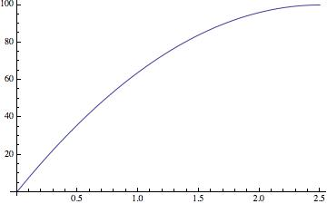

**Page 112: # 16, 26.**

**Problem 16:**

**(i) **

**(ii) **

**(iii) **

**(iv) **

**(v) **

**(vi) **

Towns that are growing: {i, ii, iv}

Towns decaying: {iii, v, vi}.

Fastest growth: iv, 18.5%

Fastest decay: v, 22%

Largest initial population: iii, 2500

Smallest initial population: 600

**Problem 26:**

1. 25
2. 15%
3. 4.92186010851807



**Page 120: # 22, 34, 36.**

**Problem 22:**



**Problem 34:**

a) 

b)



c)

Linear: 

Exponential:



**Problem 36:**



**Page 127: # 4, 18, 40**

For question #40, read example 3, posted class notes lesson 3.3;

Also, in #40, be aware that **t** is the number of years since 1994.

**Problem 4:**

f(x) is decreasing the fastest

h(x) is decreasing the slowest

g(x) is in the middle.

**Problem 18:**

**a)**



**b)**



Problem 40

a) 

b) The function S(t) seems to fit the data well, however there may be some floating point imprecisions.

c) 42.335759%

d) The sales in the year 2010 should be approximately 4710.725252 million.